# NOTES ON USING FREQCHECKMENU

1. **Overview**

The application works by reading in raw and recode frequencies from specified frequency files and storing the frequency data in CSPro data files. Raw frequencies are read into a file called AFREQ.DAT and recode frequencies into VFREQ.DAT, using options on a menu. A third option “Generate combined frequency listing" then generates a file showing the raw and recoded frequencies side by side. The user must first specify which raw frequencies are presented in the report with which recode ones, this is done by putting entries in vars.dat. This is a CSPro file with a dictionary but for the moment the user should just open it as a text file and complete it.

1. **Completing vars.dat**

The structure of vars.dat is:

Column 1 starting at position 1: name of recode variable

Column 2 starting at position 13: name of main raw variable

Column 3 starting at position 25: name of secondary raw variable (if more than one variable is used to construct the recode variable). Columns 4-7 can be used to add more raw variables, see vars.dcf for starting column positions.

For recode variables derived from multiple response alpha variables, the character ‘@’ can be appended to the root of the variable name in the vars.dat (or hvars.dat/mvars.dat) file, this will instruct the system to attempt to match each dichotomous recode variable against the original alpha frequency. An example is shown below, where variables HV237A-Z are referenced in one line as HV237@

*hvars.dat entry*

Sometimes frequency files will contain several frequency listings for the same variable. When reading the frequency file the program will treat the additional copies of variables as separate variables with ‘_x’ added to the variable name (where x is 1, 2, 3, …).

1. **Specifying which frequency files to read**

This is done by modifying the following parameters in freqcheckmenu_HR.pff (or freqcheckmenu_IR.pff/freqcheckmenu_MR.pff). Note the frequency files must be the standard text file batch frequency output directly from CSPro.

RawDataFreqs – frequency file for raw data

RecodeDataFreqs – frequency file for recode data

1. **Running the menu and generating the combined frequency listing**

To run the menu run the FreqCheckMenu application.

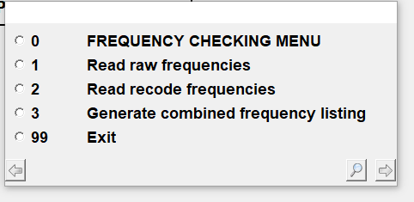

Use options 1 and 2 to read in the frequencies. They are stored in data files afreqs_?R.dat and vfreqs_?R.dat respectively (where ? is H (household), I (individual), or M (man) so they don’t need to be read in each time the menu is run unless the frequencies have changed.

Use option 3 to generate the combined listing. This is stored in freqlisting_?R.txt. It will be displayed in the system default app for .txt files once generated (usually notepad).

1. **Combined frequency listing**

The listing will present recode and raw frequencies side by side based on the information in the vars.dat, hvars.dat or mvars.dat file. If there is more than one raw data variable associated with the recode variable in vars.dat it will be shown below the table for the recode and first raw data variable.

The system will show a “*” character against any entry for which the N’s don’t match between raw and recode, this does not necessarily mean there is an error but it facilitates quick checking for variables for which there is a one to one correspondence between raw and recode categories.

Examples:

